D205 Assessment

Menachem Korn

1. **­Question of Interest**

Which county has the least percent of customers with internet per state? Answering this question could help identify where to target marketing campaigns for internet providers.

**A1. Meet the Data**

The data needed to answer the question includes the customer and location tables from the churn database, alongside the services.csv file, to retrieve internet provider information.

The columns from the customer table needed are:

Customer_id, text primary key.

Location_id, Integer foreign key.

The columns from the location table needed are:

Location_id, Integer primary key.

State, text.

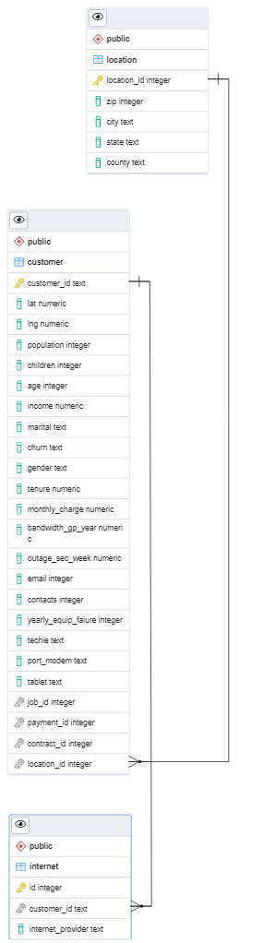

County, text.

The columns used from the services.csv file are:

Customer_id, text foreign key.

internet_provider, text.

1. **ERD**

Included to the right is the ERD for

The tables used in the query.

**B1.** **Creation of the Internet Table**

Below is the SQL query used to create the table for the csv data:

CREATE TABLE internet (

id SERIAL PRIMARY KEY,

customer_id TEXT NOT NULL,

internet_provider TEXT NOT NULL,

CONSTRAINT fk_customer

FOREIGN KEY(customer_id)

REFERENCES customer(customer_id),

CONSTRAINT customer_unique

UNIQUE(customer_id));

**B2.** **Loading Data into the Internet Table**

Below is the SQL query used to load data in the newly created table from B1. Due to the presence of extra columns in the csv file which were irrelevant to the query, a temporary table was created. All the data from the csv file was loaded into it, thereafter the relevant data was copied into the above table:

CREATE TEMPORARY TABLE t (

customer_id TEXT PRIMARY KEY,

InternetService TEXT,

Phone TEXT,

Multiple TEXT,

OnlineSecurity TEXT,

OnlineBackup TEXT,

DeviceProtection TEXT,

TechSupport TEXT );

COPY T (customer_id,

InternetService,

Phone,

Multiple,

OnlineSecurity,

OnlineBackup,

DeviceProtection,

TechSupport)

FROM 'C:\LabFiles\Services.csv'

DELIMITER ','

CSV HEADER;

INSERT INTO internet (

customer_id,

internet_provider)

SELECT customer_id, InternetService FROM t;

1. **SQL Query**

Attached is the query used to answer the question presented above; which county has the least percentage of customers with internet per state? For multiple counties within the same state having the same percentage, precedence was given to the county with the greatest number of records on file.

WITH percentage AS (

SELECT l.county,

l.state,

SUM(CASE

WHEN internet_provider = 'None'

THEN 0.0

ELSE 1.0

END) / COUNT(*) internet_percentage,

COUNT(*) cnt

FROM customer c

JOIN internet i

ON c.customer_id = i.customer_id

JOIN location l

ON c.location_id = l.location_id

GROUP BY county, state

),

ranked AS (

SELECT county,

state,

internet_percentage,

RANK() OVER(PARTITION BY state

ORDER BY internet_percentage, cnt DESC)

r from percentage)

SELECT county, state, internet_percentage

FROM ranked

WHERE r=1

ORDER BY state, county

**C1. Output.**

Attached is an output file of the above query named D205MenachemKorn.xls.

**D. New Data**

The data from the add on file must be updated right before the launch of a new marketing campaign, as well as daily throughout the campaign.

**D1. Data Reload Intervals**

The data should be updated before the launch of the campaign, to ascertain which clients changed their internet service provider due to marketing efforts. It would be counterintuitive to claim a customer signed up for internet due to the campaign, when possibly they signed up for service between the determination of marketing targets, and the public launch of the campaign.

So too, the data should be updated daily after public launch, to gain live insights into the success of the marketing efforts. The updated data may also be used for further A/B testing purposes, helping determine which approach garners the most subscriptions, adapting the strategy being used in future efforts. Through updating the data daily, we ensure the information gathered and insights observed will be the most up to date.

**E. Panopto Videos**

<https://wgu.hosted.panopto.com/Panopto/Pages/Viewer.aspx?id=78f5ba9c-3a94-436b-8c3f-b0b1002c18d1>

**E1. Panopto Video of Programs**

<https://wgu.hosted.panopto.com/Panopto/Pages/Viewer.aspx?id=1c9ed7ec-9779-46cb-838b-b0b1002e1a71>

**F. Web Sources**

No web sources or third-party code were used for the creation of this document or the completion of the assessment.

**G. Web Sources**

No sources or third-party code were used for the creation of this document or the completion of the assessment.